1. **Write a map reduce program to remove commas present inside the double quotes.**

**DRIVER CLASS:**

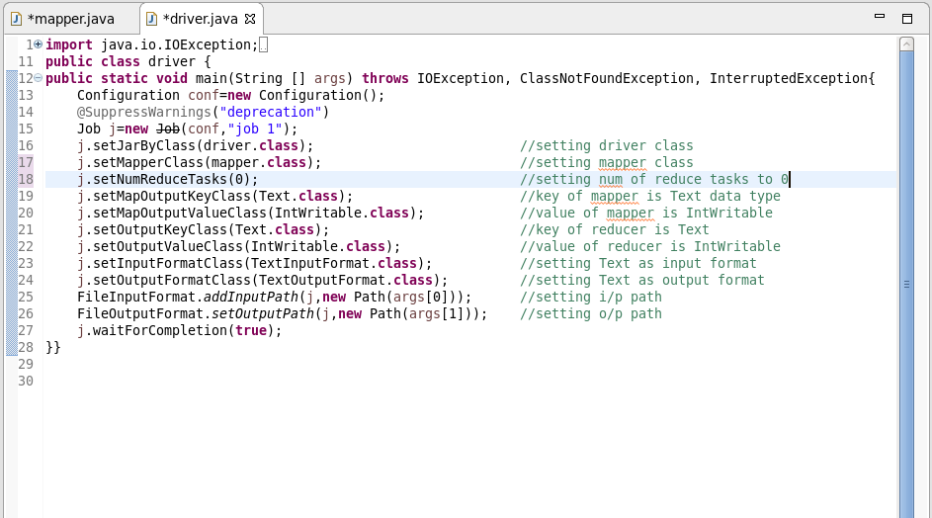

**MAPPER CLASS:**

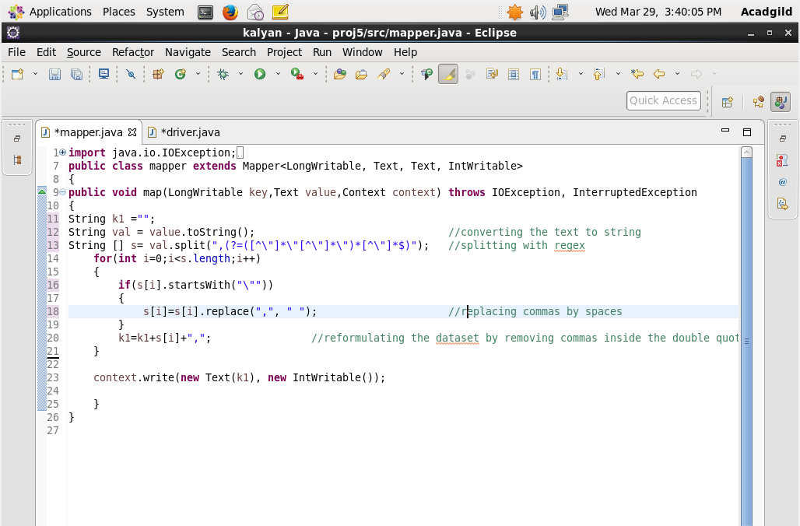

**OUTPUT:**

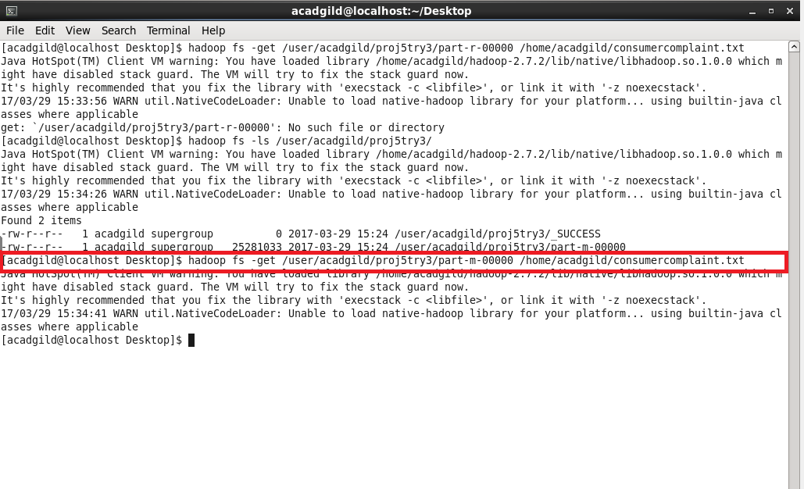

**2.**

**a) Write a pig script to find no of complaints which got timely response.**

**COMMAND:**

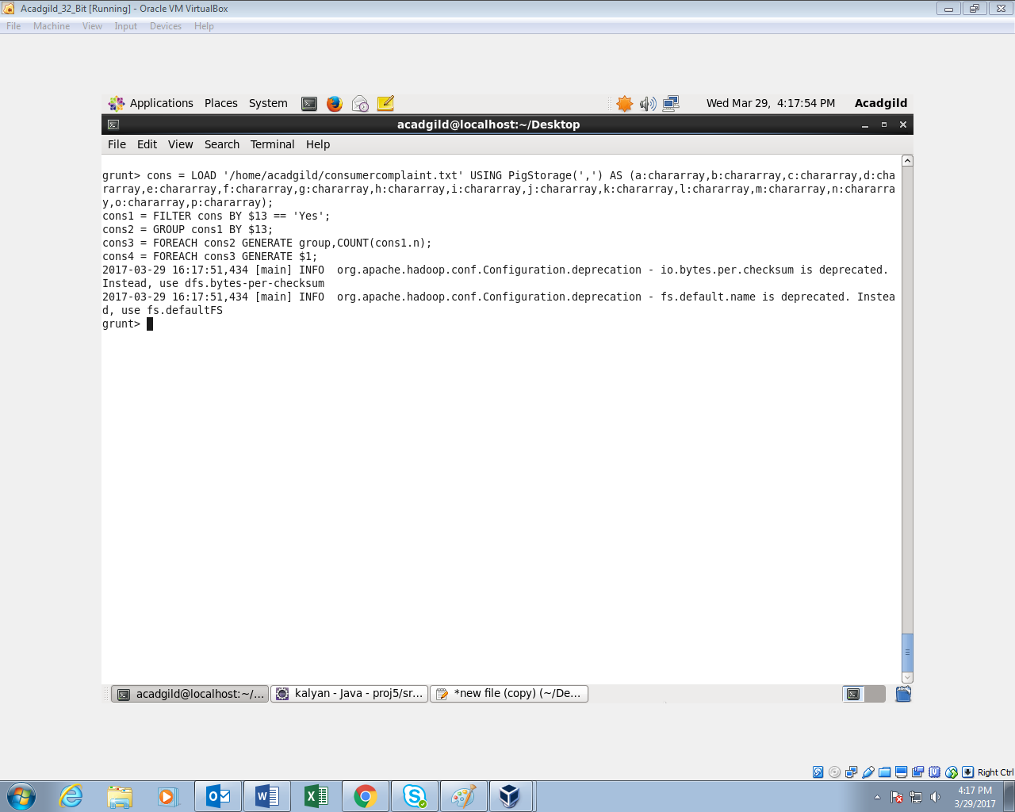

**OUTPUT:**

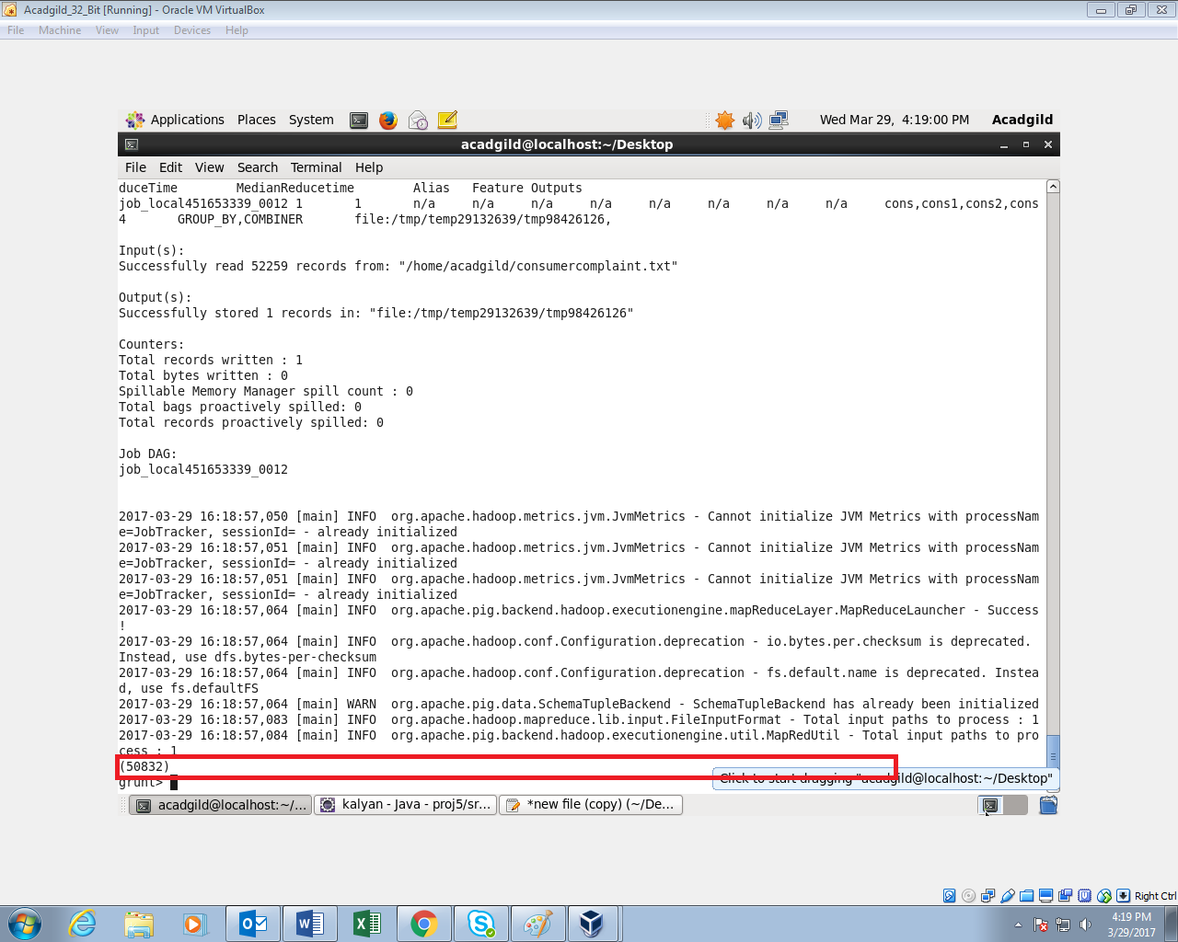

**b)** **Write a pig script to find no of complaints where consumer forum forwarded the complaint same day they received to respective company**

**COMMAND:**

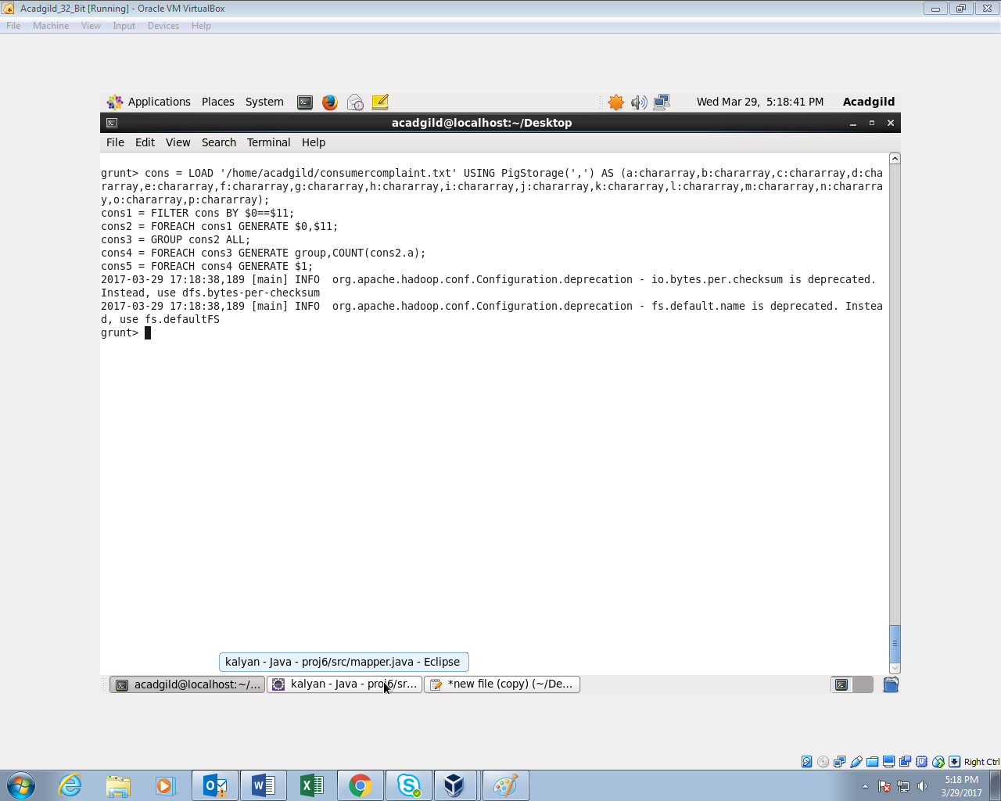

**OUTPUT:**

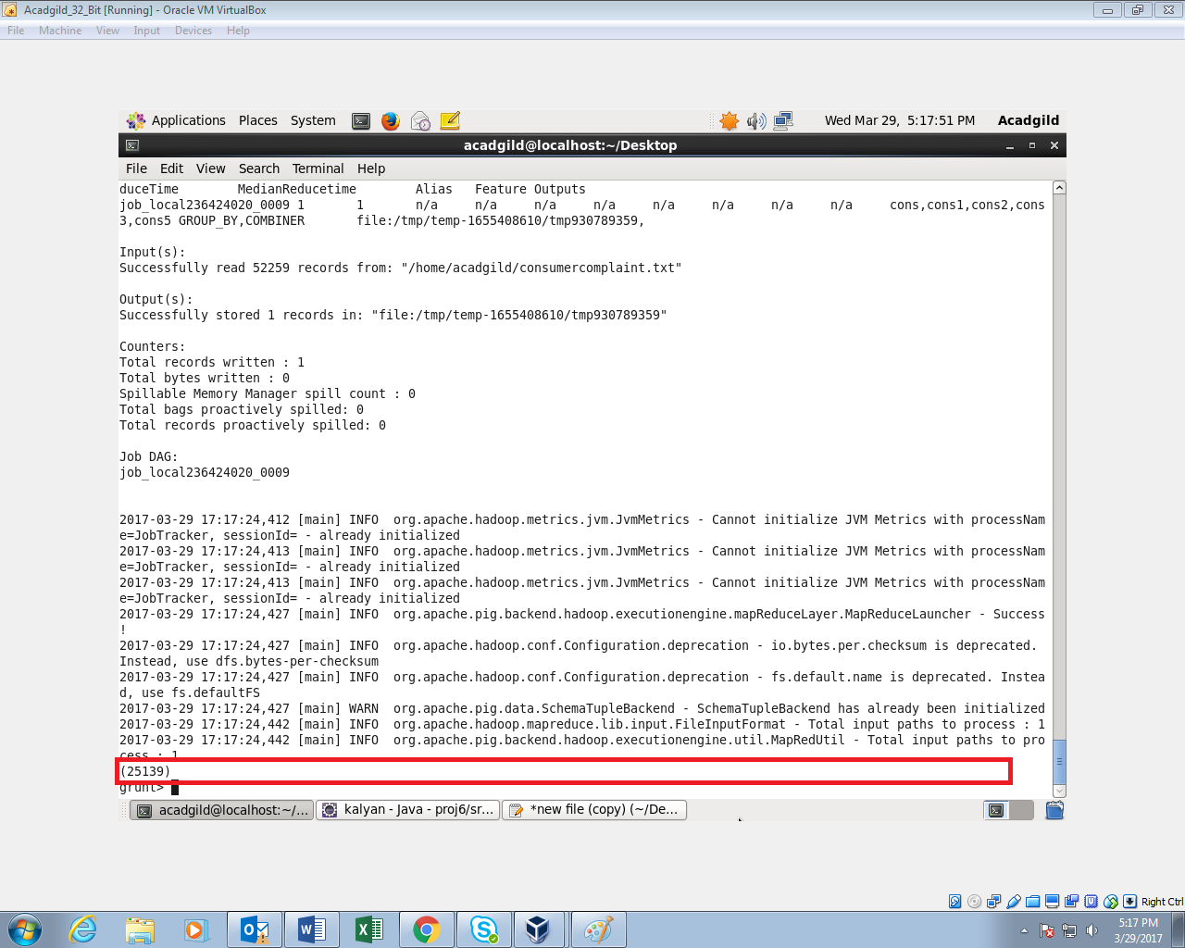

**c)** **Write a pig script to find list of companies topping in complaint chart (companies with maximum number of complaints)**

**COMMAND:**

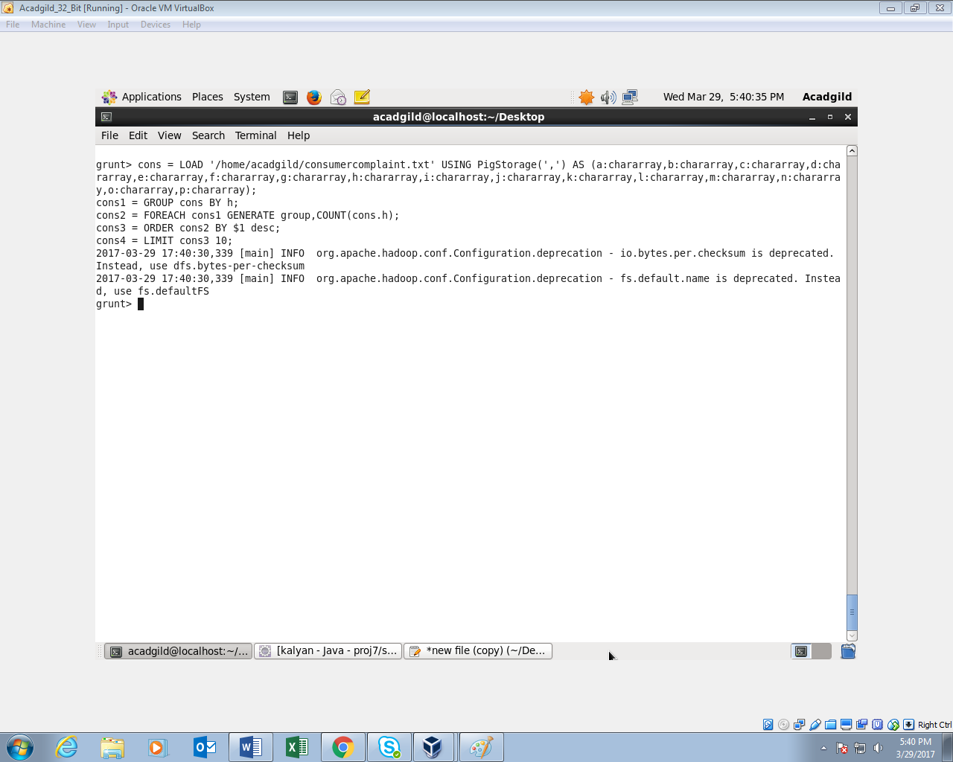

**OUTPUT:**

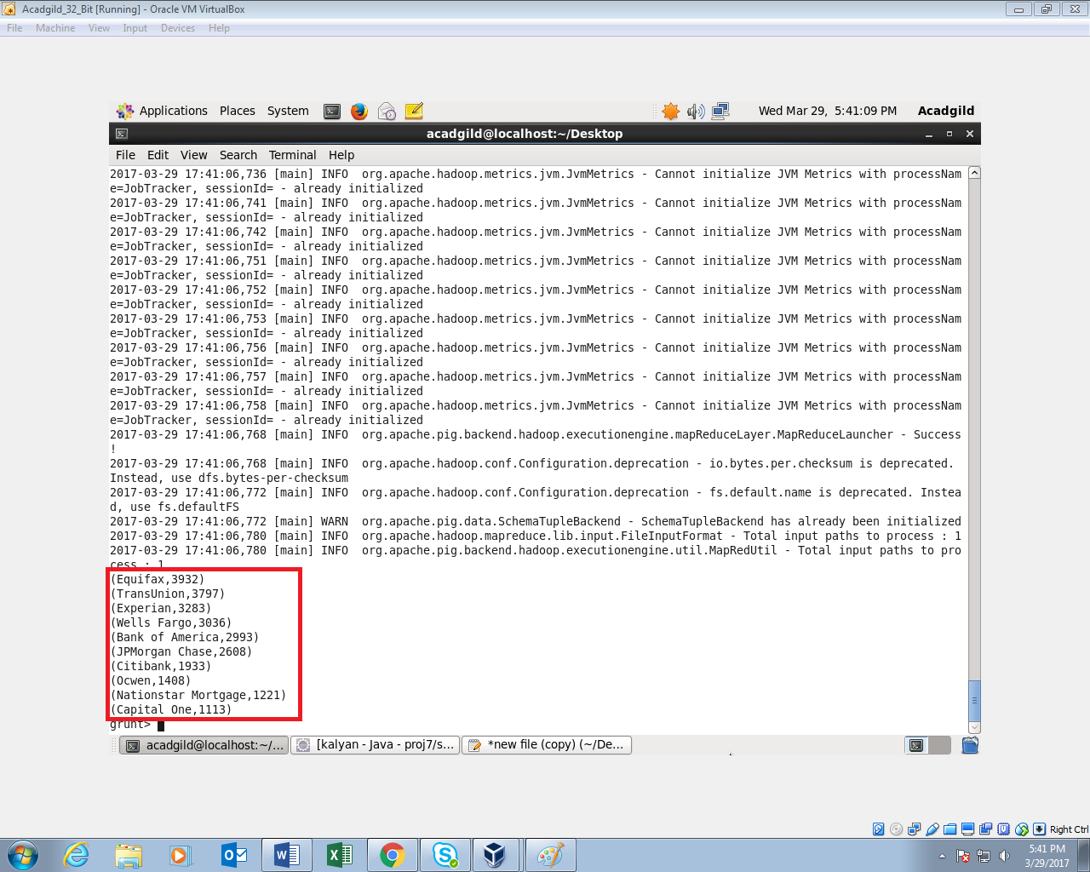

**d)** **Write a pig script to find no of complaints filed with product type has "Debt collection" for the year 2015**

**COMMAND:**

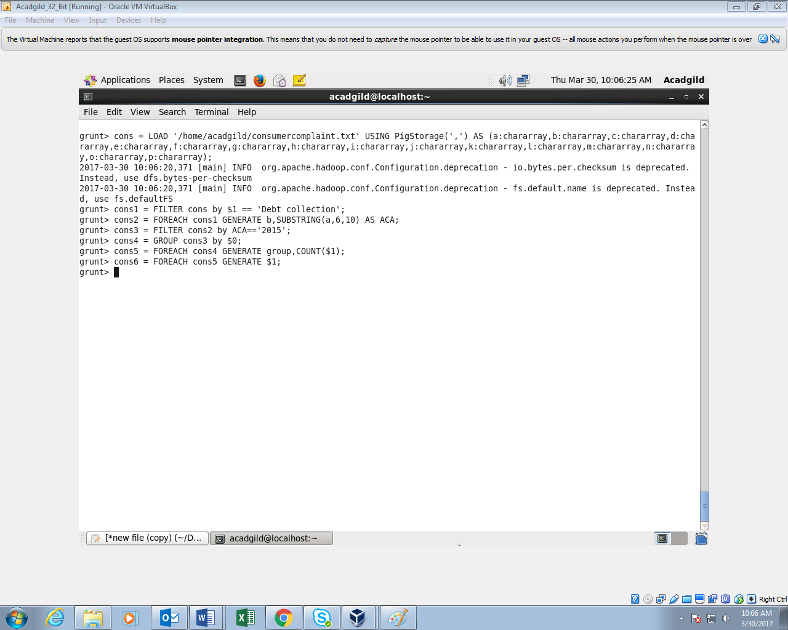

**OUTPUT:**

